Login to PLYSSQL147p

Open SQL Server Management Studio.

Select the database **Allergan.**

**Generating History Data:**

1. Run the below query.

This will display the latest Data Month name for Netherlands. Here, latest month is M112012.

select * from Allergan_Load_Details where country = 'NL'

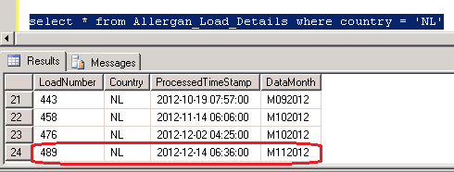

2. Run the Below query with the Latest Data Month Load Number.

This will display the backup data of M112012 Which was loaded in last production run.

select * from Allergan_Output_History where loadNumber = 485

3. Run the Below SP which will load the latest production period data from Production

Server (PLYSSQL147P) to Development Server (PLYSSQL146D)

EXEC dbo.usp_Populate_History_Data 'NL','MmmYYYY'

where mm = Current Production Month Number (01, 02, ... 11,12)

and YYYY = Current Production Year.

4. Run the below query to check whether the latest production period data loaded or not

select * from Allergan_Load_Details where country = 'NL'.

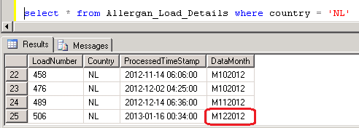

5. Run the **MergePacks.exe** from D:\FTP\MergePacks tool\

6. Click on Build Report

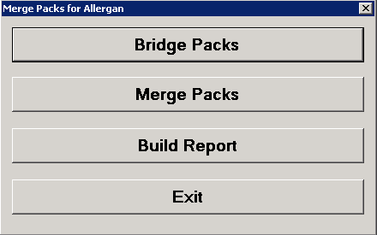

7. Select Country = NL and Previous Build = Previous Month. Click OK

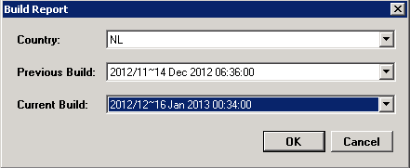

8. After successful run Below window will appear and the History Correction Report will generate at D:\FTP\MergePacks tool\Reports

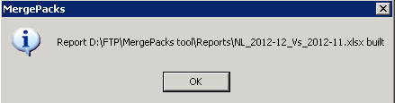

9. Copy the report file and backup at D:\FTP\MergePacks tool\Reports\YYYY\YYYYMM

where MM = Current Production Month Number (01, 02, ... 11,12)

and YYYY = Current Production Year.

10. Download the history excel file into Local and rename

History_Corrections_Netherlands_monYYYY.xlsx

where mon = Current Production Month Name

and YYYY = Current Production Year.

This file should mail to Allergan with delivery mail.

**Input Flat File vs Output Data:**

1. Login to 162.44.12.72 server.

2. Copy the input zip file **Netherlands_A067_YYYYMM.ZIP** from production server (PLYSSQL147P) D:\Allergan\Archive\Netherlands and paste at the location \\162.44.12.72\d$\Allergen\Netherlands\YYYYMM

where MM = Current Production Month Number (01, 02, ... 11,12)

and YYYY = Current Production Year.

3. Copy the output file **Netherlands_MMYYYY.csv** from production server (PLYSSQL147P) D:\FTP\Allergan_Production_Output\Renamed_Outputs and paste at the location \\162.44.12.72\d$\Allergen\Netherlands\YYYYMM

where MM = Current Production Month Number (01, 02, ... 11,12)

and YYYY = Current Production Year.

4. Create the QC File QA_Netherlands_YYYYMM.txt

where MM = Current Production Month Number (01, 02, ... 11,12)

and YYYY = Current Production Year.

5. Unzip the file **Netherlands_A067_YYYYMM.ZIP.** Open all the 3 files **A067.csv, Netherlands_MMYYYY.csv** and **QA_Netherlands_YYYYMM.txt**  with TextPad

6. Copy any single line from input flat file **A067.csv** and paste into **QA_Netherlands_YYYYMM.txt.** Make sure the selected record is the latest month record

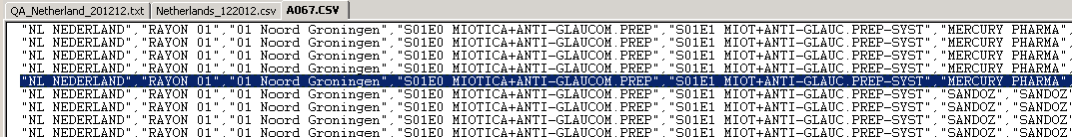

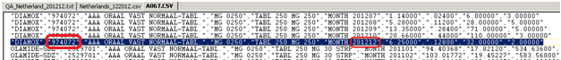

7. In the output **Netherlands_MMYYYY.csv** select 4 measures records where SKU (PackId) matches with the selected Input file record.

For example : in the below record

SKU = 974022 Brick Code = 02

Additional Checking

Brick = 01 Noord Groningen

ATC = S01E0 MIOTICA+ANTI-GLAUCOM.PREP

Manufacturer = MERCURY PHARMA

8. Match the measure values of COUNTING UNITS, PRESCRIPTIONS, UNITS and Sales Values of input vs output.

9. Select at least 8 records and do the same.

**Summary File Checking**

1. Open the Summary File **NetherlandsSummary.txt** from Production Server (PLYSSQL147P) from the location D:\FTP\Allergan_Production_Output with TextPad

2. Check the ratio with the Previous month vs Current month.

3. Check if the ratio decrease of previous vs current for any measure, rest 2 will decrease also

NL;S01E0 MIOTICA+ANTI-GLAUCOM.PREP;ACTAVIS;1;COUNTING UNITS;**4183.050;3792.815**

NL;S01E0 MIOTICA+ANTI-GLAUCOM.PREP;ACTAVIS;1;PRESCRIPTIONS;**321.559;323.479**

NL;S01E0 MIOTICA+ANTI-GLAUCOM.PREP;ACTAVIS;1;UNITS;**836.610;758.563**

NL;S01E0 MIOTICA+ANTI-GLAUCOM.PREP;ACTAVIS;1;VALUES;**1762.202;1593.654**

4. Check if the ratio increase of previous vs current for any measure, rest 2 will increase also

NL;S01E0 MIOTICA+ANTI-GLAUCOM.PREP;PFIZER BV;103;COUNTING UNITS;**9034.811;10087.311**

NL;S01E0 MIOTICA+ANTI-GLAUCOM.PREP;PFIZER BV;103;PRESCRIPTIONS;**1398.964;1546.540**

NL;S01E0 MIOTICA+ANTI-GLAUCOM.PREP;PFIZER BV;103;UNITS;**3613.920;4034.919**

NL;S01E0 MIOTICA+ANTI-GLAUCOM.PREP;PFIZER BV;103;VALUES;**61798.158;68997.297**